BUSINESS ANALYTICS REPORT
Customer Churn Analysis: ABC Communications Ltd.

By
Ibtihaj Shuaib
Programme: Data Analytics Internship, AnalystLab Africa

August, 2026

CONTENTS
BUSINESS PROBLEM 4
Business Problem 4
Business Objectives 4
Expected Business Value 4
DATASET OVERVIEW 5
BUSINESS DATA ANALYSIS 6
1. Overall Customer Churn 6
2. Churn by Senior Citizen 7
3. Churn by Contract Type 8
4. Churn Rate by Internet Service 8
5. Churn Rate by Payment Method 9
6. Customer Distribution by Multiple Lines 10
7. Distribution of Customer Tenure 10
8. Distribution of Monthly Charges 11
9. Monthly Charge by Churn 12
10. Customer Churn Correlation Heatmap 12
BUSINESS INSIGHTS 13
Business Insights 13
Business Risks 14
Business Opportunities 14
BUSINESS RECOMMENDATIONS 15
CONCLUSION 17

BUSINESS PROBLEM

Business Problem
ABC Communications Ltd. is experiencing customer churn and needs to identify the factors contributing to it so that better customer retention strategies can be developed.

Business Objectives
The objectives of this analysis are to:
- Understand the company’s customer base.
- Identify customer segments with higher observed churn.
- Determine whether contract type is associated with customer retention.
- Analyse the relationship between customer tenure and total charges.
- Examine the relationship between payment method, internet services and customer churn.
- Recommend strategies to improve customer retention.

Expected Business Value
The analysis is expected to support:
- Reduced customer churn.
- Improved customer retention.
- Increased customer satisfaction.
- Higher revenue and profitability.
- Better data-driven decision-making.

DATASET OVERVIEW
The analysis was conducted using a dataset containing 7043 customer records and 21 columns covering customer demographics, services, contract information, payment methods and billing information. The dataset was inspected for data quality before analysis, with no duplicate records identified and 11 blank entries in the TotalCharges column.

BUSINESS DATA ANALYSIS
The following findings were identified from the data analysis:

Overall Customer Churn

Approximately 73% of customers did not churn, while 27% churned. This indicates that more than one-quarter of the customer base left the company, highlighting customer churn as an important business concern that requires attention.

Churn by Senior Citizen

The churn rate among senior customers was 41.68%, compared with 23.61% among non-senior customers. This represents an 18.07 percentage-point difference, indicating that senior customers had a higher observed churn rate.

Churn by Contract Type

Customers on month-to-month contracts had the highest churn rate at 42.71%, compared with 11.27% for one-year contracts and only 2.83% for two-year contracts. This indicates a strong observed difference in churn rate across contract types, with customers on longer-term contracts showing substantially lower churn rates.

Churn Rate by Internet Service

Customers using fiber optic Internet had the highest churn rate at 41.89%, compared with 18.96% for DSL customers and 7.40% among customers without Internet service. This indicates that fiber optic customers had the highest observed churn rate among the three groups.

Churn Rate by Payment Method

Customers using electronic checks had the highest churn rate at 45.29%, considerably higher than bank transfer (16.71%), credit card (15.24%), and mailed check (19.11%). This suggests that electronic-check customers represent a higher-risk customer segment.

Customer Distribution by Multiple Lines

Approximately 48% of customers did not have multiple lines, while 42% had multiple lines and 10% had no phone service. This indicates that most customers had phone service, with a relatively small proportion having no phone service.

Distribution of Customer Tenure

The tenure distribution is concentrated among customers with relatively short tenure, with the frequency decreasing substantially after the first tenure interval. This suggests that a significant portion of the customer base consists of newer customers, while the number of customers with longer tenure is comparatively lower.

Distribution of Monthly Charges

Monthly charges vary considerably across customers, with a large number of customers paying around the lower-to-middle charge ranges. There are also substantial numbers of customers at higher monthly charges, indicating that the customer base includes both lower- and higher-paying customers.

Monthly Charge by Churn
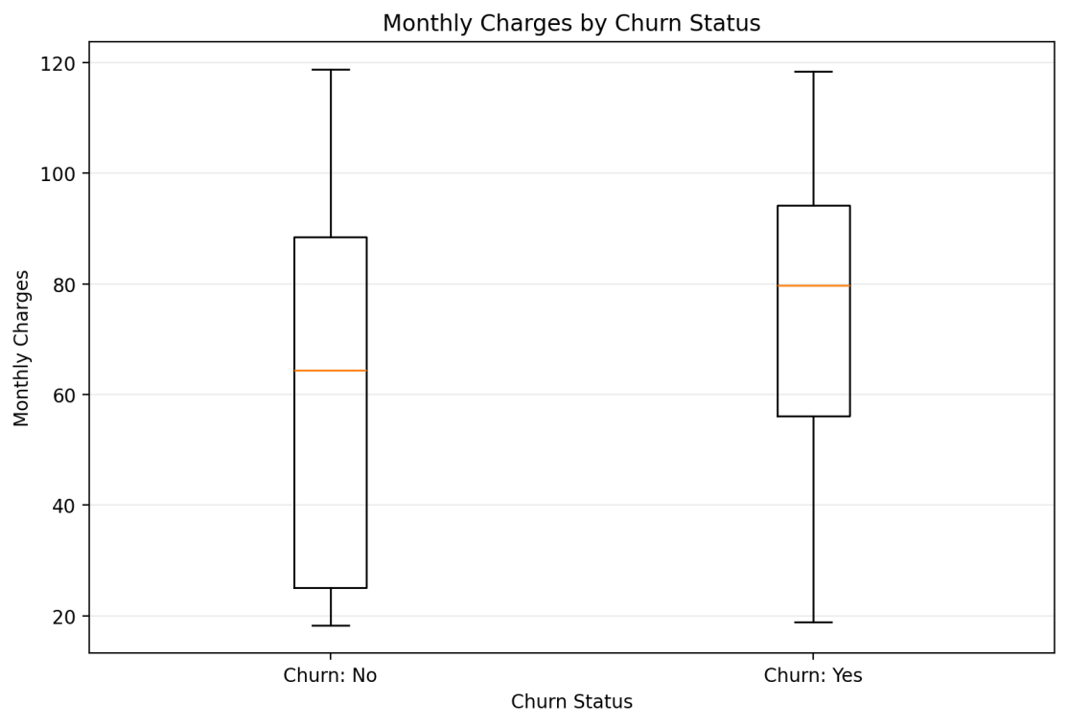
Customers who churned have higher median monthly charges (79.65) compared with customers who did not churn (64.425). The first quartile is also substantially higher for churned customers, suggesting that customers with higher monthly charges may be more likely to churn.

Customer Churn Correlation Heatmap
The correlation analysis shows a strong positive relationship between tenure and total charges (0.826), while monthly charges and total charges have a moderate-to-strong positive relationship (0.651). The relationship between tenure and monthly charges is relatively weak (0.248). This indicates that customer tenure is more strongly associated with accumulated total charges than with monthly charges.

BUSINESS INSIGHTS

Business Insights
1. Customer churn represents a significant retention challenge:
With more than one-quarter of customers leaving the company, customer retention should be treated as an important business priority. Reducing churn could help protect recurring revenue and improve the stability of the customer base.
2. Contract structure presents a major retention opportunity:
The large difference in observed churn across contract types suggests that customer commitment and contract structure are important areas for the business to examine. Longer-term customer relationships may provide greater stability than relying heavily on month-to-month customers.
3. Early customer retention should be a business priority:
The tenure distribution shows that a substantial portion of the customer base consists of relatively new customers. This creates an opportunity for the company to focus on the early customer experience, since retaining customers during the initial stages of their relationship can help build longer-term loyalty.
4. Certain customer segments require closer attention:
The analysis identified senior customers, fiber-optic customers, and electronic-check users as segments with notably higher observed churn. These segments should receive closer investigation to understand the underlying factors associated with their higher churn.
5. Long-term customer relationships have significant financial value:
The strong positive correlation between tenure and total charges (r = 0.826) indicates that customers who remain with the company longer tend to generate higher cumulative charges. This highlights the potential financial value of retaining customers over the long term.

Business Risks
1. Revenue Loss: Continued customer churn can reduce recurring revenue and overall profitability.
2. Customer Base Instability: High churn can make it difficult to maintain a stable and growing customer base.
3. Loss of High-Value Customers: Losing long-tenured customers may result in the loss of customers who have generated substantial cumulative revenue.

Business Opportunities
1. Convert month-to-month customers to longer-term contracts: The large difference in churn between month-to-month and longer-term contracts creates an opportunity to encourage customers to adopt one-year or two-year contracts.
2. Improve the fiber-optic customer experience: The high churn rate among fiber-optic customers creates an opportunity for the company to investigate pricing, service quality, and customer experience and address potential problems.
3. Develop targeted retention programmes: The company can use the identified high-risk groups, particularly senior customers, month-to-month customers, fiber-optic users and electronic-check users, to create targeted retention strategies rather than applying the same strategy to every customer.

BUSINESS RECOMMENDATIONS
1. Encourage customers to move to longer-term contracts:
ABC Communications Ltd. should develop incentives such as discounts, loyalty benefits, or additional services to encourage month-to-month customers to switch to one-year or two-year contracts, which could improve customer retention. This is particularly important because month-to-month customers had a 42.71% churn rate, compared with only 2.83% among two-year contract customers.
2. Develop targeted retention strategies for high-risk customers:
The company should identify and proactively engage customer groups with higher observed churn rates, particularly senior customers, month-to-month customers, fiber-optic users, and electronic-check users. These customers could be offered personalized support or service reviews to address potential reason for leaving.
3. Investigate the high churn among fiber-optic customers:
The company should investigate whether pricing, service reliability, network quality, or customer experience is contributing to the 41.89% churn rate among fiber-optic customers. Customer feedback and service-quality data could help identify the underlying issues.
4. Review the electronic-check payment experience:
Since electronic-check customers recorded the highest observed churn rate at 45.29%, the company should investigate whether payment difficulties, failed transactions, convenience, or other factors associated with this payment method are contributing to customer churn. The company could also promote alternative payment options where appropriate.
5. Strengthen loyalty programmes for existing customers:
Because tenure has a strong positive relationship with total charges (r = 0.826), the company should prioritize retaining existing customers through loyalty rewards, personalized offers, service benefits, and regular engagement. Retaining established customers can help protect the revenue generated over longer customer relationships.
6. Monitor churn regularly using customer data:
The company should establish a regular churn-monitoring process or dashboard that tracks churn by contract type, tenure, customer segment, internet service, and payment method. This would allow management to identify emerging high-risk groups and take action earlier.

CONCLUSION
The analysis of ABC Communications Ltd.’s customer data shows that customer churn is a significant business concern, with 26.54% of customers having left the company. The analysis identified several factors associated with higher observed churn, particularly month-to-month contracts, electronic-check payment methods, senior customers, and fiber-optic internet users.
Contract type showed one of the clearest differences in churn, with month-to-month customers recording substantially higher churn than customers on one- and two-year contracts. The analysis also showed that customer tenure has a strong positive relationship with total charges, highlighting the importance of retaining customers over the long term.
These findings provide useful evidence for developing more targeted retention strategies. By focusing on high-risk customer segments, encouraging longer-term contracts, and improving the customer payment and service experience, ABC Communications Ltd. can potentially reduce customer churn, improve retention, and protect long-term revenue and profitability.

